**Partner Plan Act Collaboration Institute**

**Request for Supports (RFS)**

**BACKGROUND**

Illinois Action for Children (IAFC) has implemented a system of statewide supports to assist community collaborations improving local early childhood systems. Known as Community Systems Statewide Supports (CS3), the supports are funded by the Illinois State Board of Education and will ensure that communities are working to help every young child – regardless of race, ethnicity, income, language, geography, ability, immigration status, or other circumstance – receive the strongest possible start to life so that they grow up safe, healthy, happy, ready to succeed, and eager to learn.

CS3 will increase Illinois’ system-building capacity through a comprehensive training and technical assistance approach. We intend to support early childhood systems-building at the state, regional, and local levels by building the capacity of a broad base of system actors to understand, practice, and support system-building efforts as they address targeted local early childhood problems.

IAFC has partnered with the Governor’s Office of Early Childhood Development, the Illinois State Board of Education and the Community Systems Development Subcommittee of the Illinois Early Learning Council to design the Collaboration Institute. We invite all early learning collaborations in Illinois to complete the RFS for the Collaboration Institute, where communities wishing to receive more in-depth support will focus on increasing enrollment in early learning programs and quality of programs serving young children and their families.

**THE COLLABORATION INSTITUTE FRAMEWORK**

Collaboration teams that are accepted in the Collaboration Institute form a yearlong cohort. Based on their RFS application, collaboration teams of 3-5 individuals will be offered one of two types of support: Coach-Guided Track and Process-Guided Track. If the collaboration wishes to include more than five people on the team, it should be discussed during the consultation call with the Director of Community Systems Statewide Supports.

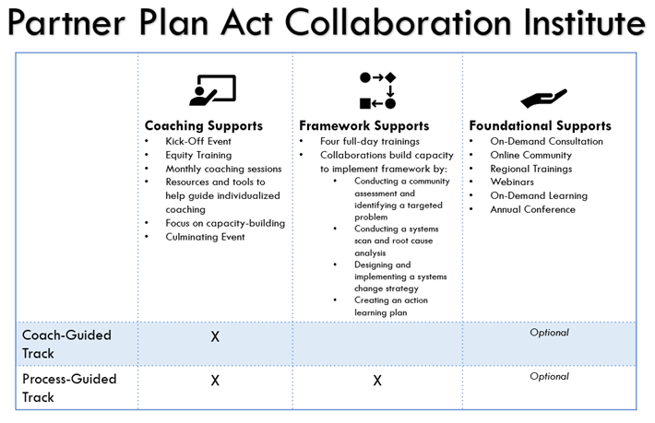***Coach-Guided Track:*** Collaborations will receive 24 hours of coaching and technical assistance in-person or over the phone.

***Process-Guided Track:*** Collaborations will receive four trainings (24 hours) based on the Collaboration Institute framework along with monthly coaching, with 24 hours of coaching for the year. The Collaboration Institute structure and supports are built upon the Community Systems Statewide Supports Framework which includes four core components.

* Community Assessment & Targeted Problem Identification
* Systems Scan & Root Cause Analysis
* Strategy Design
* Implementation & Action Learning

These components draw upon our experience with previous community systems development initiatives such as the Innovation Zones and the ABLe Change Framework developed by Drs. Pennie Foster-Fishman and Erin Watson at Michigan State University. Community systems work will be approached with the goal of equitable outcomes for all children and authentic engagement of families and community members in the process.

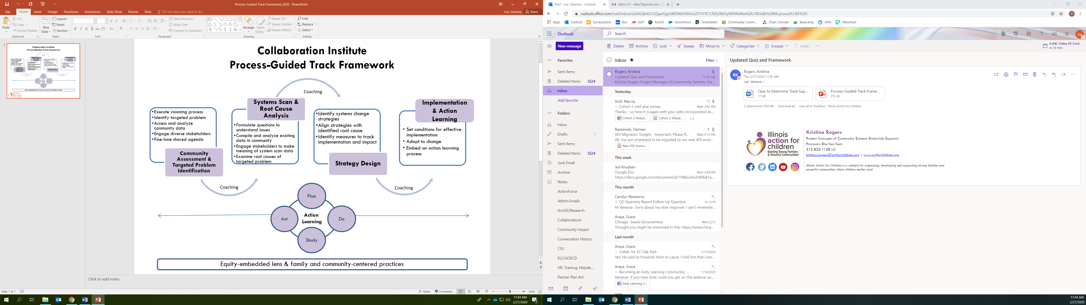

Regardless of if receiving Coach-Guided or Process-Guided supports, all Institute collaborations will receive: 1) an orientation; 2) access to an online peer learning community; 3) on-demand online modules and webinars; 4) foundational trainings; and 5) the Partner Plan Act conference.

**GOALS OF CS3**

|  |
| --- |
| **Community Systems Statewide Supports’ Goals:**  1. Increase collaborations’ understanding and use of common systems-change tools in order to increase enrollment in early learning programs and quality of programs serving young children and their families  2. Increase quality training and technical assistance for systems-change within Illinois  3. Legitimize, define, and build the capacity of collaboration leaders |

**EXPECTATIONS OF INSTITUTE COLLABORATIONS**

As Institute participants, collaborations will select a team of 3-5 individuals who will be expected to apply the concepts, tools, and methods they have learned as they execute a local systems-building/change initiative. Moreover, participating collaboration teams should have the full support of their greater collaboration and will be responsible for sharing said concepts, tools, and methods with all collaboration members. Local initiatives should tie into the state’s vision of early childhood systems collaboration and seek to address the issue that not every young child receives the strongest possible start to life so that they grow up safe, healthy, happy, ready to succeed, and eager to learn. Collaboration initiatives may be new or already underway.

Evaluation and action learning are an important part of the Collaboration Institute. The CS3 team wants to ensure that progress is being made toward both collaboration team outcomes (see above) and the CS3 team goals (see below). Teams will be asked to participate in an evaluation process which includes surveys, interviews and quarterly reports throughout the year as part of CS3’s quality improvement process. Each collaboration team will complete self-assessments (Analysis of Strengths & Growth Areas and Equity Tool) at the beginning and end of its time in the cohort. These tools will be used to help collaborations identify areas of support as well as areas of strength. They will also be expected to complete the online Early Childhood Collaboration Data Learning Course.

|  |
| --- |
| **Collaboration Teams’ Outcomes:**  1. Increase capacity for systems change leadership at the local level  2. Build an effective governance structure  3. Create systems-level change that increases enrollment in early learning programs and/or quality of programs serving young children and their families |

Acknowledging that collaboration members already have a full workload, the design and execution of these yearlong cohorts is intended to be as practical as possible. Knowing that participation will place additional demands on collaboration team members’ time, we want to clearly state expectations for your involvement and the benefits we aim for you to receive.

|  |  |
| --- | --- |
| **Community collaboration teams will be…** | |
| Expected to: | Benefits: |
| Engage in various learning opportunities including training and coaching | Learn concepts, tools, and methods to support systems-change/development work |
| Be flexible and adaptive as we engage in an action learning process with the cohort | Conduct community needs assessment, define strategies and meet the collaboration’s goals |
| Examine equity and authentic engagement of families in collaboration’s communities | Increase awareness and action related to equity and family engagement |
| Apply concepts, tools, and strategies to deepen local systems-building/change work | Enhance your system change efforts and impact |
| Work collaboratively with CS3 Trainer/Coaches and other specialized consultants | Gain personalized support tailored to your team and community |
| Participate in the evaluation process which will include surveys, interviews, and quarterly reports | Contribute to the continuous improvement of the CS3 project |
| Complete the Early Childhood Collaboration Data Learning Course during the year | Build capacity to use data for community systems development efforts |
| Attend all trainings with the entire 3-5 person team if receiving Process-Guided supports | Build the capacity of the entire team to better promote and embed practices within collaborations |
| Engage the entire 3-5 person team during the Analysis of Strength and Growth areas | Generate greater understanding of needs and buy-in for the collaboration’s CS3 goals |

**TRAINING TOPICS & SCHEDULE**

Coach-Guided

|  |  |
| --- | --- |
| Date | Topic |
| July 14, 2022 (virtual) | Cohort 4 Gathering (Orientation) |
| August – September, 2022 | Coaching  Online Peer Learning Communities |
| September 21 - 22, 2022  (virtual, subject to change) | Equity Training |
| October 2022 – June 2023 | Coaching  Online Peer Learning Communities |
| June 2023 | Partner Plan Act Conference (Bloomington)  Culminating Event |

Process-Guided

|  |  |
| --- | --- |
| Date | Topic |
| July 14, 2022 (virtual) | Cohort 4 Gathering (Orientation) |
| August 2022 – September 2022 | Coaching  Online Peer Learning Communities |
| September 21 - 22, 2022 (virtual, subject to change) | Training 1: Equity |
| September 2022 – October 2022 | Coaching  Online Peer Learning Communities |
| October 5, 2022 | Training 2A: Root Cause Analysis |
| October 26, 2022 | Training 2B: System Scan. |
| October 2022 – February 2023 | Coaching  Online Peer Learning Communities |
| February 8, 2023 | Training 3: Strategy Design |
| February 2023 – April 2023 | Coaching  Online Peer Learning Communities |
| April 12, 2023 | Training 4: Implementation & Action Learning |
| April 2023 – June 2023 | Coaching |
| June 2023 | Partner Plan Act Conference (Bloomington)  Culminating Event |

**RFS PROCESS & TIMELINE**

The RFS questions are meant to give the CS3 team a sense of your collaboration’s capacity, willingness and readiness to engage in systems-change work. Please reflect deeply as you complete your self-assessment and the respond to open-ended questions, since we will be using the information you provide to determine whether collaborations will receive Coach-Guided or Process-Guided supports.

All collaborations intending to submit an RFS must first complete a consultation call with Grace Araya, CS3 Project Director, before submitting. This is to ensure that collaborations have a clear understanding of all expectations and benefits of participating in the Collaboration Institute prior to completing a RFS. Please contact Grace at [grace.araya@actforchildren.org](mailto:grace.araya@actforchildren.org) well before the submission deadline to arrange a consultation call at which *all* collaboration team members must be present. If your collaboration is seeking to continue with cohort 5 directly from cohort 4, you may complete the consultation call with your current coach. An RFS submitted without conducting a consultation call will not be accepted.

The RFS is comprehensive. It should be completed with collaboration members and submitted by the collaboration leader. The RFS should be a maximum of seven pages and must be received by Grace Araya no later than **June 20, 2022** by the end of business day at [grace.araya@actforchildren.org](mailto:grace.araya@actforchildren.org). Please email the completed electronic file along with a scan of the signature page. Collaborations will be notified of the results by **June 27, 2022**.

When completing the open-ended questions in the RFS, please use the scoring guide at the end of this document to assist you in writing your responses.

|  |
| --- |
| **QUESTIONS?** If you have questions please contact Grace Araya, Director of Community Systems Statewide Supports at Illinois Action for Children at [grace.araya@actforchildren.org](mailto:grace.araya@actforchildren.org) or 773-564-8870. |

If you need assistance in deciding which track of supports your collaboration would like to apply for, please use the quiz below.

1. How would you describe your collaboration?
   1. Our collaboration partners and stakeholders come from diverse sectors and/or we focus on various early childhood issues.
   2. Our collaboration partners and stakeholders mostly come from one sector and/or we focus on a single issue within the early childhood landscape.
   3. Our Collaboration operates more as a networking group to share updates related to early childhood.
2. How available is your prospective 3-5 person Collaboration Institute team to participate in quarterly full-day trainings?
   1. All our team members will be available to attend 4 full-day trainings throughout the year.
   2. Our collaboration will likely struggle to have all of our members available to attend 4 full-day trainings throughout the year.
   3. Not sure.
3. Which most closely aligns with your collaboration’s reason for participating in the Collaboration Institute?
   1. We want to learn about and apply concepts, tools, and methods to support systems change using a structured framework where one skill builds upon the next.
   2. We already have a project or goal in mind and want support in reaching that goal at our own pace in a less structured setting.
   3. Not sure.
4. Which statement best describes your collaboration’s engagement with data?
   1. We want to learn how to better access and analyze community data to understand community issues.
   2. We have already accessed and analyzed community data that determined already what community issue we need support with.
   3. Not sure.
5. Which statement best describes your collaboration’s approach to continuous quality improvement (CQI)?
   1. Our collaboration seeks to improve continuously by examining our processes and outcomes.
   2. Our collaboration understands what we need to do to be better; we just require support with our goal.
   3. Not sure.

**Mostly A’s:**

It looks like the collaboration you belong to may benefit most from the Process-Guided Track.

**Mostly B’s:**

It looks like the collaboration you belong to may benefit most from the Coach-Guided Track.

**Mostly C’s**:

We recommend that you discuss your quiz results during your consultation call with CS3 Director Grace Araya to determine the best course of action for your collaboration.

**SCORING GUIDE**

A lower score does not necessarily disqualify a collaboration from receiving targeted supports. Rather, it will be used to inform what type of supports a collaboration will receive.

|  |
| --- |
| **Collaboration Team Information (10 points)** |
| Collaboration name and service area listed |
| Minimum of 3 and up to 5 members committed to full participation who are key leaders within the collaboration, including the collaboration leader and a parent/community member (if applicable) |
| **Self-Assessment (10 points) \***Note: current cohort 4 PPACI collaborations do not need to complete the Self-Assessment |
| All components completed |
| **Collaboration Overview (10 points)** |
| Has clearly defined vision/mission/purpose |
| Has clearly defined and distributed leadership |
| Meets on a regular basis |
| Has a clearly defined governance and decision-making structure |
| **Community Information (10 points)** |
| Describes community |
| Lists assets & strengths of the community |
| Lists challenges & needs of the community |
| **Diverse Perspectives (10 points)** |
| Actively engages stakeholders from across sectors |
| Actively works to engage parents and community members |
| Actively identifies and works on minimizing or eliminating barriers to participation/engagement |
| Actively works to align efforts toward a shared vision |
| **Activities & Strategies (20 points)** |
| Has or wants to address an issue related to the state’s early childhood vision |
| Has identified the priority populations |
| Strategies used demonstrate commitment to priority populations |
| Strategies used demonstrate commitment to community systems-change/development |
| **Capacity & Readiness (10 points)** |
| Has indicated how much time will be allocated to Institute work |
| Has willingness and desire to learn ways to integrate system-building/change approaches |
| Shows readiness to work on increasing enrollment or quality of early learning programs |
| Demonstrates commitment to using data and evaluation to guide continuous improvement |
| **Skill Development & Goals (10 points)** |
| What collaboration hopes to gain from participation |
| Challenges that collaboration hopes to address as a result of learning new practices and methods for systems-change and strategy design |
| **Team Selection (10 points)** |
| Demonstrates attempt to incorporate team members from a variety of sectors |